Document Title | Document Code | Document Type | Issue No | Sop No.
Shared Service  Release Management | S-SW-RM | SOP | 01 | 6 SS
Issue Date | Effective Date | Copy No. | Revision No.
01/10/2025 | 01/10/2025 | Master | 0

Purpose
Standardize the deployment of software updates, patches, and new features across AKG subsidiaries through a coordinated, risk-minimized release process. Ensure zero unplanned downtime, regulatory compliance, and seamless integration with subsidiary operations.

Procedure & Flow
Step 1: Release Planning & Scheduling
- Action:
  - Consolidate release calendar from all subsidiaries.
  - Define maintenance windows aligned with subsidiary low-activity periods.
- Roles:
  - Software Manager: Approves master release calendar.
  - Subsidiary Liaison: Confirms subsidiary availability.
Step 2: Pre-Release Validation
- Action:
  - Deploy to staging environment; execute smoke, regression, and performance tests.
  - Validate subsidiary-specific configurations.
- Roles:
  - Team Lead: Manages testing.
  - Subsidiary Users: Verify critical workflows.
Step 3: Change Advisory Board (CAB) Approval
- Action:
  - Present release scope, risk assessment, and rollback plan to CAB (includes subsidiary reps).
  - Obtain sign-off.
- Roles:
  - CAB Chair (Director of ICT): Final approval.
  - Subsidiary Liaison: Represents subsidiary interests.
Step 4: Deployment Execution
- Action:
  - Deploy to production via automated pipelines (e.g., Jenkins, GitLab CI/CD).
  - Monitor systems for 24h using APM (Application Performance Monitoring) tools (e.g., Datadog, New Relic).
- Roles:
  - Full stack Engineer: Executes deployment.
  - Systems/Server Admin: Infrastructure support.
Step 5: Post-Release Activities
- Action:
  - Conduct subsidiary smoke tests.
  - Document lessons learned; update runbooks.
- Roles:
  - Shared Service Coordinator: Surveys subsidiary satisfaction.
  - Team Lead: Retrospective report.

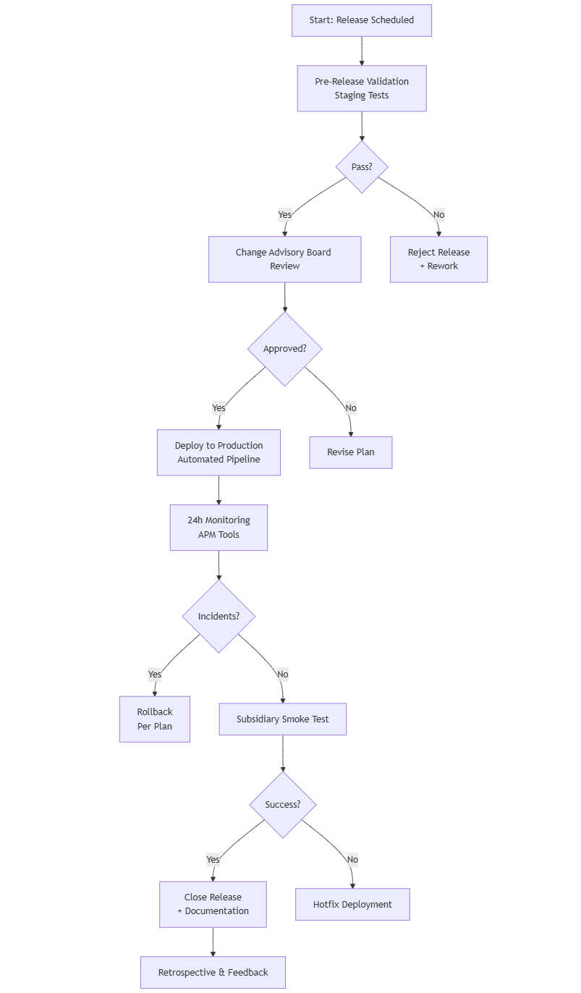
Forms
Form Name | Form Code
RELEASES LOG | F-SW-RM/01

Revision History
Rev No | Rev Date | Issue No | Issue Date | Description of Change | Approved By
0 | 29-09-2025 | 01 |  | Initial Issue

